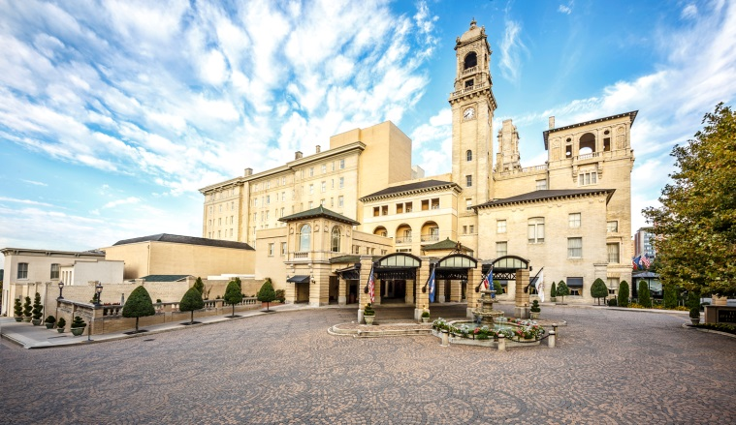
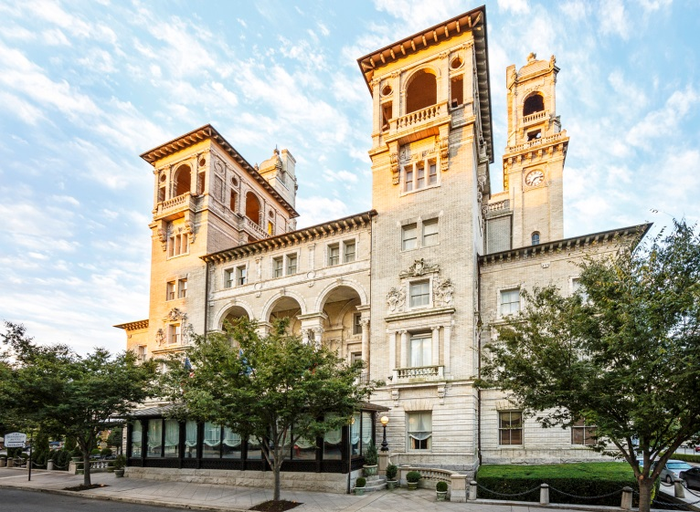
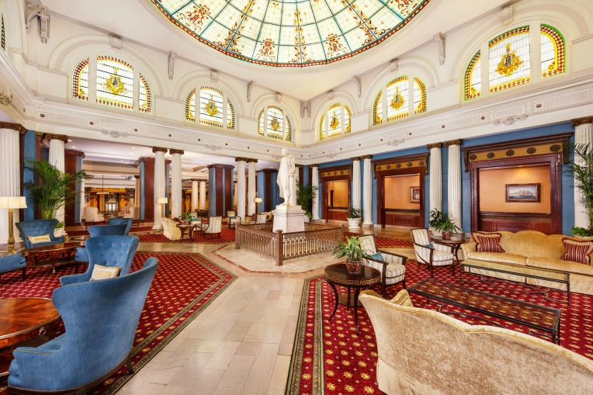
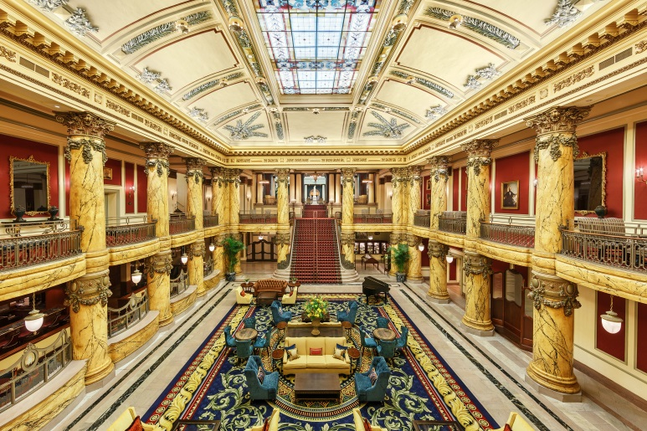

DISCOVER

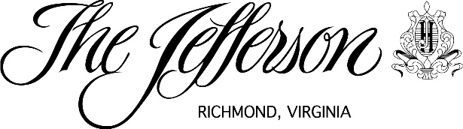

Since 1895, The Jefferson Hotel has provided visitors
to the Richmond Region with an extraordinary travel experience in the heart of downtown. Over the ensuing decades, The Jefferson has become synonymous with extraordinary dining, breathtaking architecture, flawless service and Richmond.

Stay in Comfort
Residential luxury. Calculated comfort. The Jefferson's 181 guest rooms and suites are reminiscent of an upscale downtown apartment right down to the doorbell. The enlarged footprints are enhanced by the rich fabrics, fine craftsmanship and unexpected details. Welcoming guest room foyers with live plants, spacious dressing areas and beautiful marbled baths complete the residential feel given to each room.
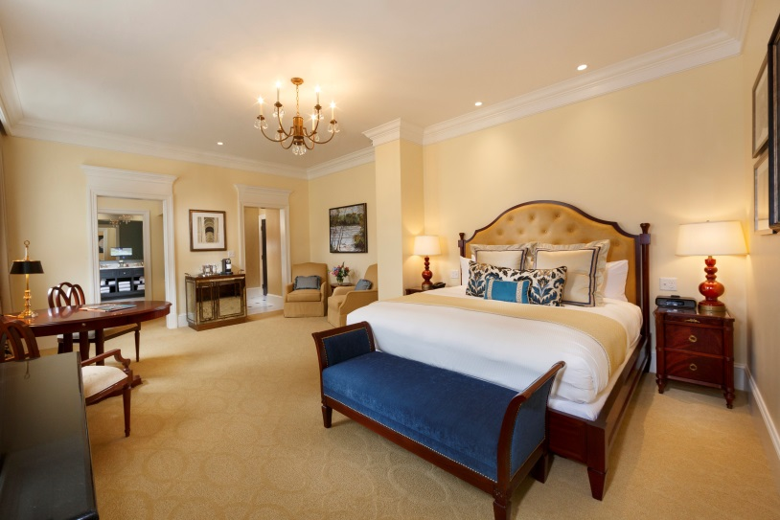
Amenities Include:
- Custom mattress sets, luxury bed linens and plentiful pillows
- High-definition, large screen television with premium cable and casting capabilities of your own content
- Nespresso coffee maker and complimentary supplies
- Complimentary high-speed wireless Internet access and local calls
- Evening turndown service
- Molton Brown bath product, luxurious bath linens and plush bathrobes
- In-room safe and electronic doorbell with do not disturb

Relax in Luxury
Indoor Pool
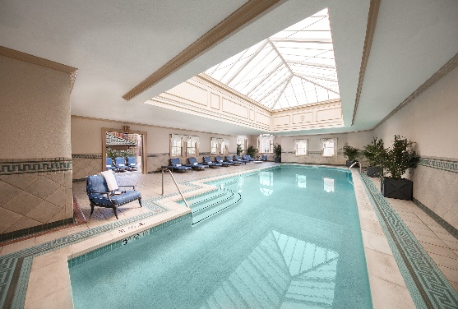
The indoor swimming pool is a welcome oasis for relaxing, completing a work-out or splashing with the kids. Comfortable lounge chairs, plush pool towels and plenty of natural light make this a comfortable place to enjoy a good book and a cool beverage. An outdoor sundeck adjacent to the pool is available for sun seekers.

Fitness Center
Whether you prefer cardiovascular exercise equipment, weight training machinery or free weights, there is a wide selection of the most up-to-date equipment, including Peloton bikes, at your disposal in this 3,000 square foot facility.

Concierge Service
Our friendly and efficient concierge staff is available to assist with your every need or request, including our complimentary downtown car service from 7:00 a.m.-11:p.m. daily. Advanced reservations are recommended and can be made by contacting the concierge directly at 804.649.4615.

Salon Vivace at The Jefferson
Rejuvenate with a massage in our peaceful treatment rooms or in the privacy of your guest room. Pamper yourself a little – or a lot. Additional services for hair, skin and nails available in a calming, chic environment.

Shopping
While enjoying the beauty of the Rotunda Lobby, stop in Gators Gifts and Coffee Bar for a freshly brewed cup of coffee or to find that perfect souvenir amongst a delightful selection of Jefferson logo items, children’s gifts and locally crafted jewelry

CONTACT INFORMATION
Jennifer Crisp, Public Relations Manager
804.283.1594
Please visit our on-line press room and image library at www.jeffersonhotel.com.

Dine Like A Local
Lemaire
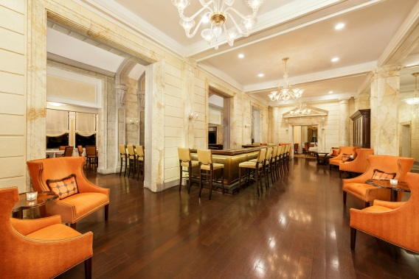
Regionally inspired. Masterfully crafted. The Jefferson Hotel has a rich history of creating extraordinary dining experiences that are memorable in every way. Four truly distinctive Richmond dining options are available – Lemaire, TJ’s, Afternoon Tea, and Sunday Champagne Brunch. Each menu features locally-sourced, sustainable ingredients and the Southern influences of Richmond’s food culture. Dishes are created for seasonal freshness and flavor to be both delicious and beautiful. Gracious and knowledgeable service bring visitors and residents back again and again to share a meal with friends and family at a Richmond landmark, The Jefferson Hotel.

Meet flawlessly
Grand Ballroom
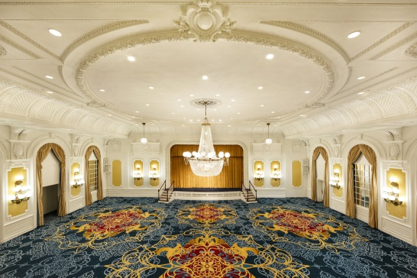
Expert execution. Flexible functionality. We believe that attention to detail is the key to every successful meeting. Our team averages over a decade of tenure at The Jefferson allowing them to not only create meeting experiences that exceed expectations but to anticipate needs, opportunities and pitfalls. In additional to exceptional service from the point of inquiry through to a fond farewell, the 26,000 square feet of functional and exceptionally beautiful event spaces are a unique offering of The Jefferson.

